OPIP-4000C
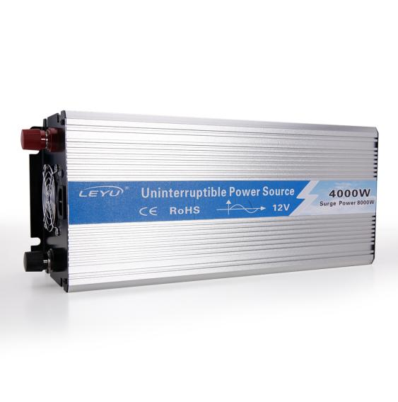
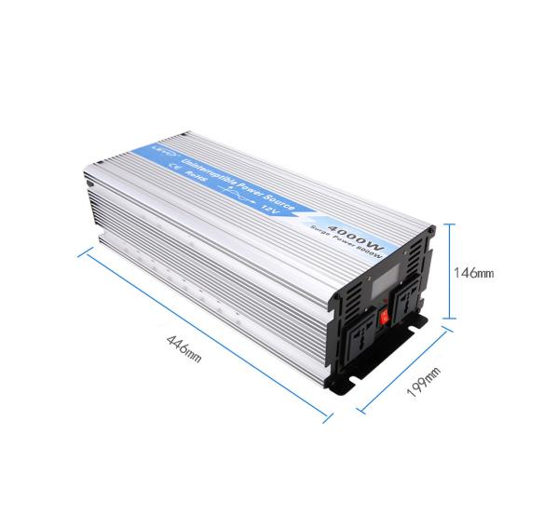
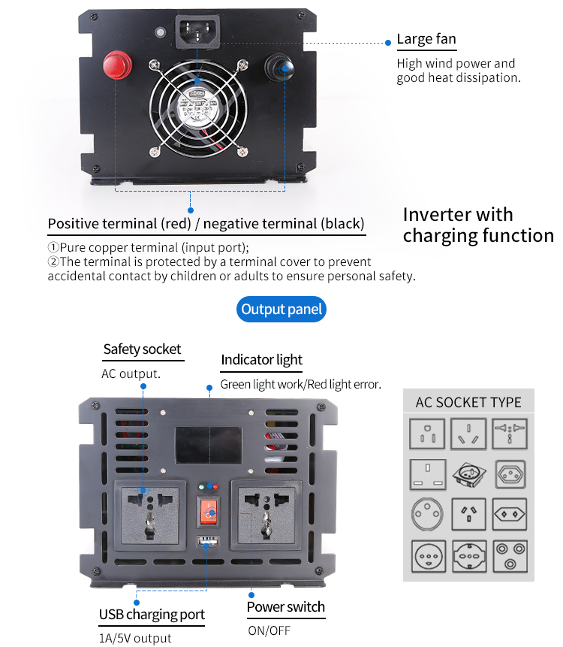
Pure Sine Wave Inverter
Rated Power: | 4000W | Frequency: | 50Hz / 60Hz
Peak Power: | 8000W | Unit Size: | 446*199*146mm
Waveform: | Pure Sine Wave | Unit Weight / G.W.: | 10100g / 12300g
DC Input Voltage: | 12V / 24V | Box Size: | 575*285*240mm
AC output Voltage: | 110V / 220V | Quantity/CTN: | 1PCS

Technical parameters
Model | OPIUP-4K-1 | OPIUP-4K-1 | OPIUP-4K-1 | OPIUP-4K-2 | OPIUP-4K-2 | OPIUP-4K-2
Rated power | 4000W
Peak power | 8000W
Input voltage | DC12V | DC24V | DC48V | DC12V | DC24V | DC48V
Output voltage | 100VAC or 110VAC or 120VAC±5% |  |  | 220VAC or 230VAC or 240VAC±5%
Unload current less than | 0.8A | 0.5A | 0.2A | 0.8A | 0.5A | 0.2A
Output frequency | 50Hz±0.5Hz or 60Hz±0.5Hz
Output waveform | Pure Sine Wave
Waveform distortion | THD<3%(Linear load)
USB port | 5V 1A
Max.efficiency | 90%
Input voltage range | 10-15.5V | 20-31V | 40-61V | 10-15.5V | 20-31V | 40-61V
Low voltage alarm | 10.5±0.5V | 21±0.5V | 42±1V | 10.5±0.5V | 21±0.5V | 42±1V
Low voltage protection | 10±0.5V | 20±0.5V | 40±15V | 10±0.5V | 20±0.5V | 40±15V
Over voltage protection | 15.5±0.5V | 31±0.5V | 61±1V | 15.5±0.5V | 31±0.5V | 61±1V
Low voltage recover | 13±0.5V | 24±0.5V | 48±1V | 13±0.5V | 24±0.5V | 48±1V
Over voltage recover | 14.8V±0.5V | 29.5V±0.5V | 59V±1V | 14.8V±0.5V | 29.5V±0.5V | 59V±1V
Protection function | Low voltage |  | Alarm at first, voltage continously reduce. LED Red light on & shut sown.
Protection function | Over voltage |  | LED Red light on, shut down
Protection function | Over load |  | LED Red light on, shut down
Protection function | Over temperature |  | Alarm at first, tempurature continously rise.LED Red light on & shut sown
Protection function | Short circuit |  | LED Red light on
Protection function | Input reverse polarity |  |  | Fuse burn-out
Working temperature | -10°- +50°
Storage temperature | -30°- +70°
Dimension(mm) | 446×199×146mm
Packing(mm) | 575×285×240mm
Net./gross weight(g) | 10100/12300g
QTY/Ctn | 1 Pcs
Meas./Ctn(mm) | 575×285×240mm
Gross weight/Ctn(g) | 12300g
Warranty | 2 years
Configuration | Standard
Cooling method | Intelligent air cooling
Note | Our products update constantly.The technical parameter is for reference only.Please refer to our real product.
Wanjia Industrial Park, Beibaixiang Town, Yueqing City, Zhejiang Province, CHINA

